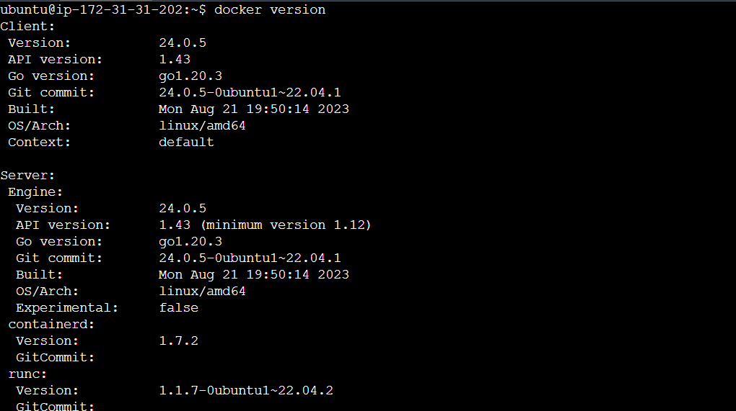

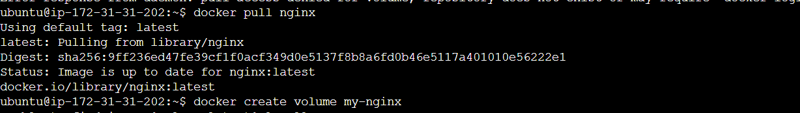

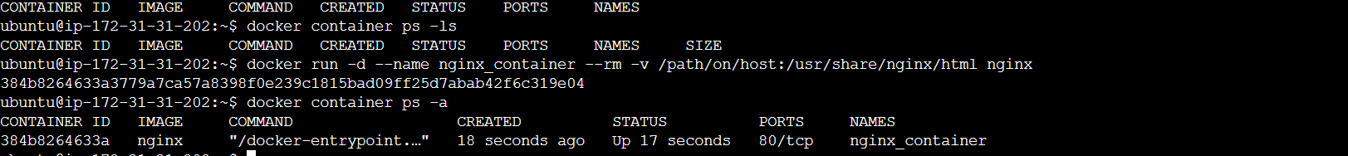

When using docker inspect <container_id> | grep IPAddress

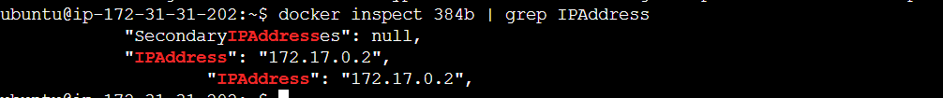

docker network ls && docker inspect bridge commands   
